

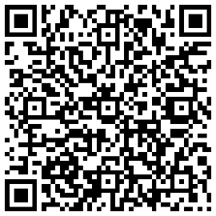

**How to self-refer**

**Online Form**

Please scan the QR code to the right or by visiting: <https://www.northerntrust.hscni.net/services/physiotherapy-services/physiotherapy-service-outpatient-service/musculoskeletal-msk-physiotherapy-self-referral/>

**Paper Form**

Self-referral forms are available in both your GP practice and in your local physiotherapy department.

**Self-Referral to Physiotherapy**

**Scan the QR Code to access physiotherapy resources**

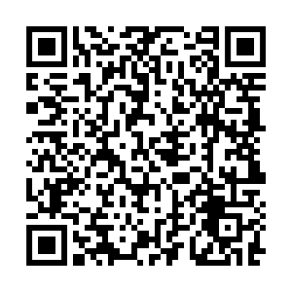

**Who should speak to their GP first?**

* If you are under the care of a consultant for the same issue
* If you require a home based appointment
* If you are seeking treatment for a neurological, respiratory, obstetric, gynaecological or continence issue
* If you are experiencing pregnancy related pain
* Have a red, hot, swollen joint
* Have a fever, or feel unwell
* Have a history of cancer

**Who can self-refer?**

You are 16 years or older, reside in the Northern Trust, Have a neck or back problem, joint or muscles pain, or a recent injury such as a sprain or strain

**You can now refer yourself to musculoskeletal physiotherapy without a visit to your GP!**